101100010 FROM BASE 2 TO 8

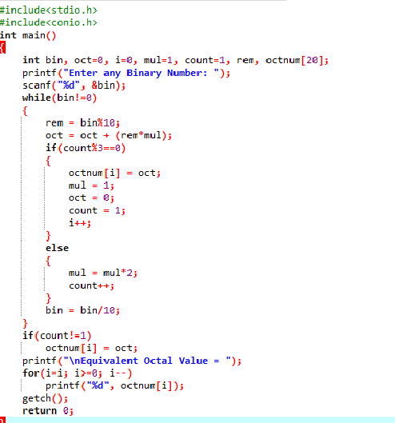

OUTPUT

